Assignment 7

Domain Name Server (DNS)

By Ziming Song

[zs2815@nyu.edu](mailto:zs2815@nyu.edu)

# **Part 1: Setup DNS Resolution**

R1

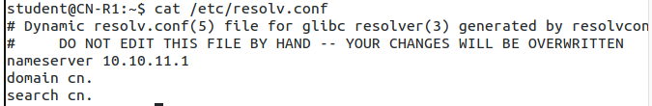

R2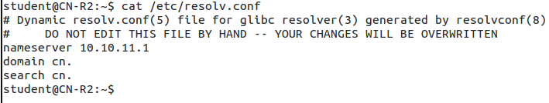

R3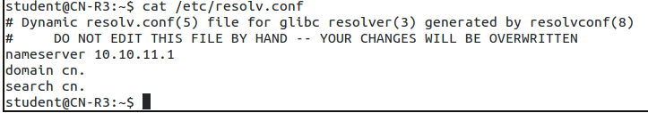

R4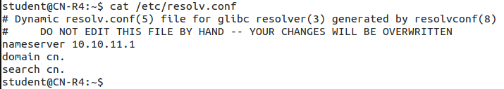

Ubuntu

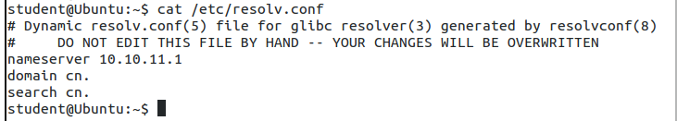

Kali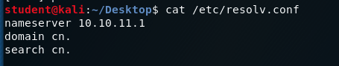

# **Part 2: Configuring the Primary Zone**

## **Forward and Reverse zone files for primary DNS server.** **[20 points]**

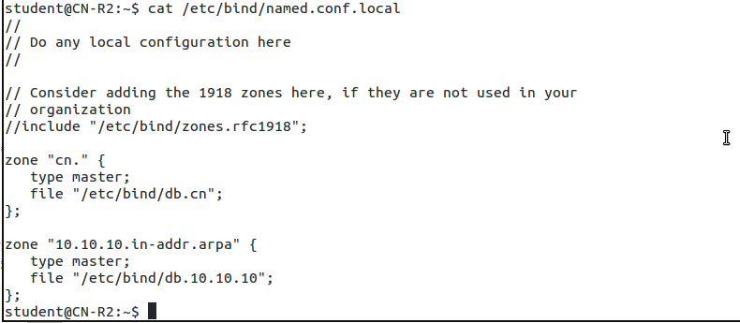

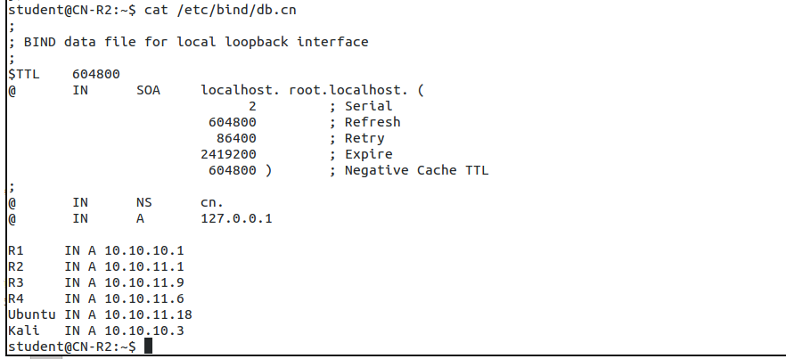

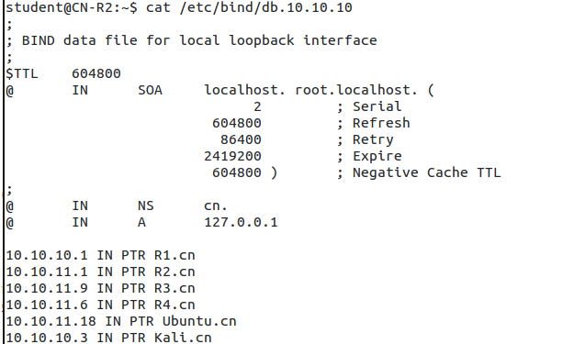

## **Host lookup by name using nslookup or dig [15 points]**

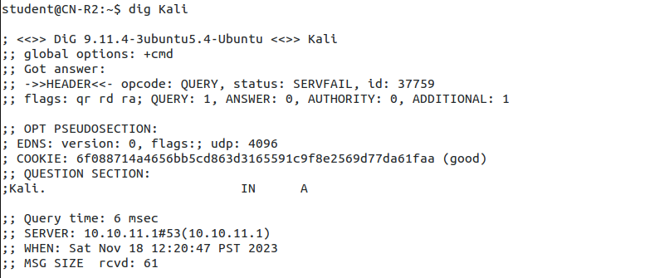

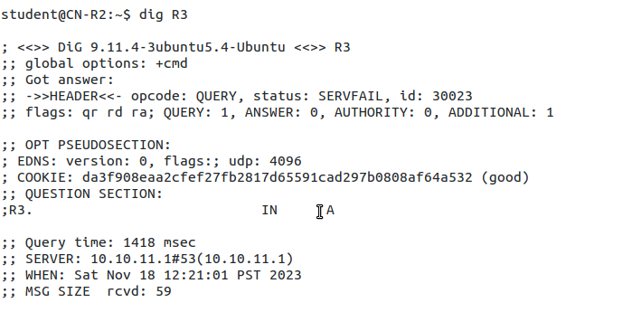

## **Host lookup by address using nslookup or dig [15 points]**

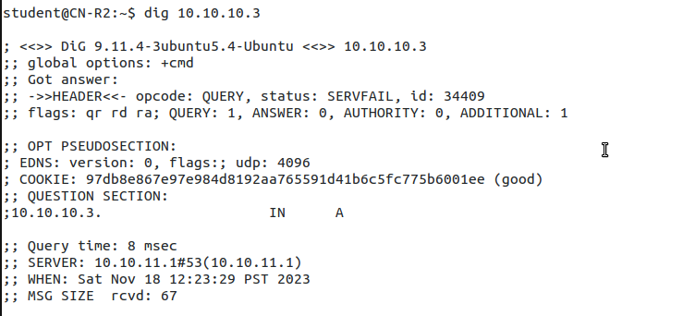

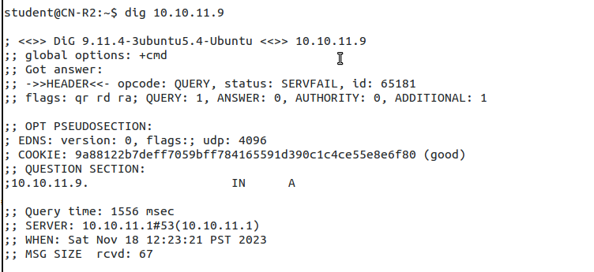

## **Screenshots of R1 pinging R2 and Kali [20 points]**

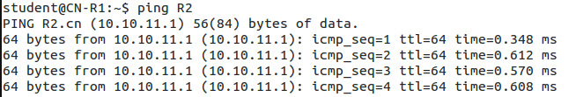

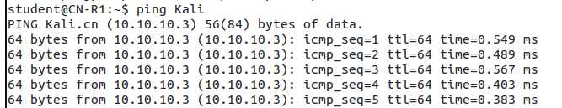

## **Screenshots of R2 pinging R3, R4, and Ubuntu[30 points]**

